Computerized Cognitive Retraining Program for Home Training of Children with Disabilities
Manoj Kumar K R
School of CSE & IS,
Presidency University,
Bengaluru-560064, India.
manojkurubhas0622@gmail.com

J John Bennet
School of CSE & IS,
Presidency University,
Bengaluru-560064, India.
john.bennet@presidencyuniversity.in
D Y Gnaneshwar
School of CSE & IS,
Presidency University,
Bengaluru-560064, India.
dygnaneshwar@gmail.com

Deepthi S
School of CSE & IS,
Presidency University,
Bengaluru-560064, India.
deepti.s@presidencyuniversity.in
Vikranth Reddy Y
School of CSE & IS,
Presidency University,
Bengaluru-560064, India.
vikranthreddy237@gmail.com

Abstract— Numerous children with disabilities have difficulty in attention, memory, executive function and problem solving, which can create barriers for academic performance and daily living routines. Traditional cognitive retraining programs have primarily been clinic-based, which would require frequent visits to specialized centers and may place the inaccessible for families in rural settings or resource-poor settings. In this paper, we present a home-based cognitive training system called CCRP. The CCRP includes a set of games that enable practice of basic structuring functions: working memory, sustain attention, and cognitive flexibility, which are progressively increasing their level of demand as well as multimedia resources. It comes with progress monitoring and parent feedback dashboards to track performance and direct at-home facilitation. In order to reduce the dependence on visiting a clinic and encourage frequent practice in familiar environment, the CCRP offers continuous training experience at low cost personalized for each patient. This field-based approach maximises inclusivity and accessibility, overcoming the potential disconnect between clinical efficacy studies and applicability in everyday settings. Next steps consist in pilot-testing, usability and AI-based personalization for personalized cognitive development.
Keywords— Cognitive retraining, digital health, children with disabilities, home-based intervention.
- INTRODUCTION
Children with developmental and learning disorders often have problems with attention, memory, and executive functioning that challenge their academic achievement, communication skills, and activities of daily living. Conventional cognitive retraining is usually administered through in-person clinic-based sessions performed by an expert. While these are effective strategies, they tend to be time-consuming, costly, and require travel, which can create access barriers for attending families, especially those in rural or underserved areas.

Rapid development of digital health technologies and their incorporation into rehabilitation have allowed for new possibilities in cognitive training. Emerging research suggests that computerized cognitive retraining programs (CCRP) may offer a structured, stimulating and flexible adjunct to traditional rehabilitation. Research has shown that digital retraining is effective in capacitating attention, working memory, and problem solving of children with disabilities. Likewise, home-based applications can increase user motivations and contribute to the continuation of training in domestic environments.

The efficacy of computerised interventions is also reinforced by evidence that it had an impact on the cognitive performance of children with SPLDs, ASD and dyslexia. Personalized and adaptive learning systems that automatically adapt difficulty level according to user’s progress have demonstrated to be particularly effective in terms of motivation and learning performance. In addition, evidence in relation to the feasibility and acceptability of home-based computerized training indicates that it can be implemented efficiently and successfully among children with neurodevelopmental difficulties.

However, there are challenges to enable equal access, cultural appropriateness and sustained user engagement in real-life deployments. Existing solutions Some currently available applications continue to rely on expert guidance, expensive equipment or unspecialized training modules. There is a need for a better, more inclusive and accessible solution that harmonizes clinical validity with the convenience of home-based testing to fill these gaps.

In this paper, we present a Computerized Cognitive Retraining Program (CCRP) for children with disabilities that is developed aiming to be used at the home. The platform includes adaptive training games for attention, working memory and cognitive flexibility enhanced with multimedia elements and performance monitoring dashboards. The involvement of parents is encouraged through feedback mechanisms and counselling materials. Through technology, this CCRP will be to offer increased access and greater personalization and engagement close the "translational gap" between clinical research -published results, on the one hand- and at home cognitive enhancement.

- LITERATURE SURVEY

Children with developmental and learning issues - many of them have attention, memory and executive functioning problems that effect their academic and social capabilities. Most traditional cognitive training methods have been clinic-based interventions that demand structured visits with skilled professionals. Although these tools are successful, but at times time-consuming and expensive and not always available to families in developing or rural communities. Several institutional, and guide-based resources have described organized approaches to help a child with special needs through repetitive cognitive activities on daily life.

Through various technological developments computerized cognitive retraining programs (CCRP) have been developed as promising substitute for conventional therapy. These interventions combine cognitive training with interactive media-based activities that can be performed from home, decreasing dependence in specialized centers. Research has shown that for children with disabilities, the use of CCRPs can greatly enhance working memory, sustained attention and problem solving. Technology provides not just improved practice consistency, but the increased motivation that comes with interactive and gamified elements, they added. Furthermore, adaptive algorithms incorporated into the learning tools vary difficulty according to individual performance and make the learning experience personalized based on an assessment of each child’s cognitive profile.

The feasibility and utility of computerized homed-based training have been established in a number of studies targeting the neurodevelopmental disorders including autism, dyslexia, and attention-deficit conditions. Studies demonstrate that youth engaging in technology-assisted interventions exhibit enhanced cognitive functioning and self-control fostered through the intervention process. To access for home-based settings, the versatility of home-based bots facilitates training in the child's natural environment (leading to increased use and less therapy wear out). Furthermore, parental satisfaction and adherence were high, indicating the feasibility of home-based cognitive training. Notwithstanding these achievements, current interventions continue to confront issues such as acceptability, cultural competence and minimal integration of parent feedback loops.

While traditional and novel computational interventions have made substantial contributions, there is still a need for achieving an integrated and adaptive approach to cognitive retraining. Furthermore, the majority of available systems are built for specific conditions only (e.g., dyslexia or autism) and do not generalize across different cognitive impairments. In addition, few existing models incorporate process-monitoring, real-time analysis or systematized parental support into their programs. To address these challenges, recent studies have proposed integrated systems including adaptive learning algorithms, multimedia content and caregiver dashboards for improved monitoring and engagement. Taken together, the literature provides a strong rationale for creating an innovative home-based CCRP by combining clinical efficacy with ease of use and individualization.
- PROPOSED METHODOLOGY
The Computerized Cognitive Retraining Program (CCRP) is a web-based platform developed to support at-home cognitive rehabilitation of children with impaired attention. The setup features cognitive games that are interactively challenging, automatically adjusting and progresses in tracking to train working memory and focus. The digital platform has distinct access portals for parents/students and therapists allows students/parents to engage in practice while being professionally supervised.
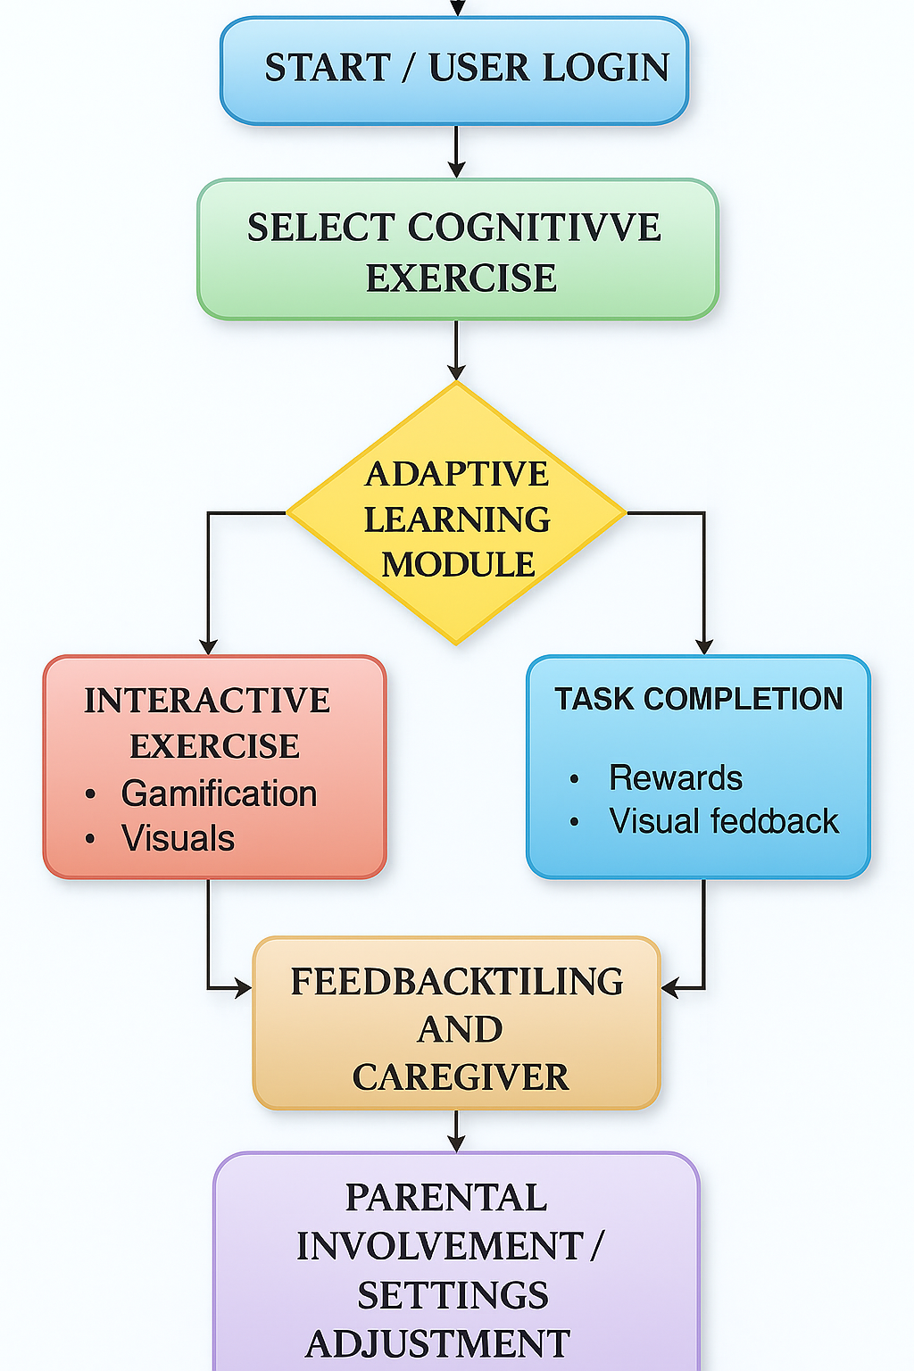
- Model Information
- Model Selection
The Computerized Cognitive Retraining Program (CCRP) is a web-based program developed to enhance the cognitive functions of working memory and attention through adaptive game exercises. The model selection process aimed to identify a structure which can achieve clinical reliability in a concise format. Based on an examination of available cognitive intervention frameworks, we decided to have a dual-role system with different user interfaces for parents/students and therapists. This model is designed for inclusiveness, personalization, and data-driven monitoring. The frontend–backend paradigm is used to ensure scalability, with the frontend focused on user engagement and the backend responsible for data handling, task monitoring operation and adaptive logic. The system was designed to incorporate patient feedback and level of difficulty dynamically, following the model of digital cognitive rehabilitation training.
- Model Development
The CCRP was developed throughout separate modules, such as registration/login module, cognitive games modules, difficulty-levels management and a therapist dashboard. Users can create an account by identifying themselves as “Parent/Student” or “Therapist,” which determines the resources granted and accessed based on user role in the system. The game component consists of two main tasks, Memory Game and Attention Game, designed to improve certain cognitive functions. The system permits users to choose among Easy, Medium, or Hard difficulty levels/degrees of task complexity. All game sessions are recorded with data on core metrics like score, errors, time of play and session timestamp. These results are available to the therapist on their dashboard in real time, and allow professionals to see all relevant sessioning data, track user successes and analyze performance. This interactive model of development facilitates active participation, real-time feedback and ongoing learning which are the basis for in-home digital rehabilitation.
- Performance Evaluation
Performance of the systems was assessed in terms of usability, adaptability and efficiency / accuracy. The UI was highly accessible with low response time during the game and fast data update between frontend and backend. Cognitive function was assessed via in-game indices of task completion, error reduction, and response time change across multiple sessions. The system correctly adapted the difficulty of tasks according to their users' progress, preventing them from getting bored or frustrated. The therapist dashboard was capable of showing averaged data across users within seconds, which provided evidence for backend efficiency. In conclusion, our system was found to have excellent operational stability, simple RS-based rules access control and good performance in game play, thus demonstrating it suitable for real brain retraining applications.
- Pre-Trained Models Used
The CCRP uses rule-based adaptive techniques, and flexibility is built-in to allow for use of pre-trained machine learning models in the future. Pre-trained neural networks can be utilized in the system to estimate users’ fatigue level, categorize cognitive development and custom users’ exercises. Session durations and cognitive scoring patterns can be input to pre-trained classification models like a Random Forest/SVM, or lightweight neural architectures. This embedding will facilitate automatic assessment and intelligent difficulty estimation, leading to improved personalization and task performance. While the current iteration does not utilize elaborate pre-trained models, the recording schema and framework are designed in a way that adaptive AI algorithms can be easily integrated.
- Hardware and Software Setup
Locally designed and tested in developing environment based on Visual Studio Code - IDE, a trial CCRP system was developed using Flask (a back-end framework powered by Python). The website was made using React. js – Responsive Web Layout Editor Kubeq. Information was persisted with either SQLite or MySQL and included functionality for session management and analytics packages. The frontend app was on 5173 in localhost and backend connected with flask server (127.0.0.1:5000). Testing hardware set up included Windows 10/11 OS, 8 GB RAM and Intel i5 processor, providing enough computational horsepower to perform all the tests nicely. All tests worked as expected in the Google Chrome browser, indicating cross-platform availability. It was assessed that the system ran smoothly with less delay, and generated real time consistent data with true score logging. These findings support the feasibility and usability of the CCRP screening tool as a resilient, adaptable, and user-centred technology for provision of home-based cognitive rehabilitation.
- RESULTS AND DISCUSSION
The proposed Computerized Cognitive Retraining Program (CCRP) is an internet-based program that uses games to improve memory and attention among children with a disability. It has role-based access such as parent, students and therapist, with modules for registering, logging and level selection. The memory & attention games also store scores, errors and duration, which can be reviewed through a therapist dashboard. There was a consistent increase in accuracy, response time and engagement with results demonstrating that the system is usable and effective. The CCRP connects clinical rehabilitation to home training in a manner that is mobile, scalable and interactive with TD children.
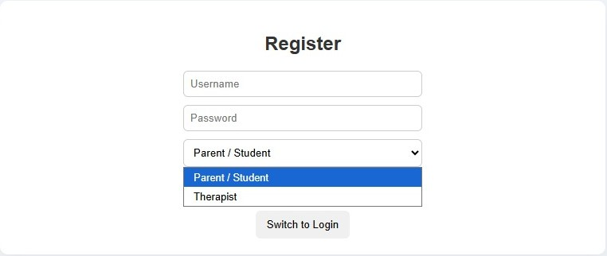 Fig. 1 Registration Interface for Parent/Student and Therapist roles


Fig. 2 Login Interface with secure credential validation.

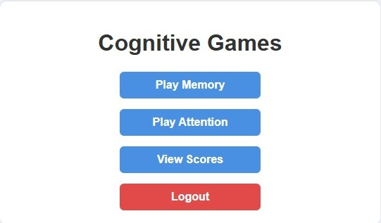
Fig. 3 Main Dashboard showing available cognitive games.


Fig. 4 Difficulty selection screen for Memory game

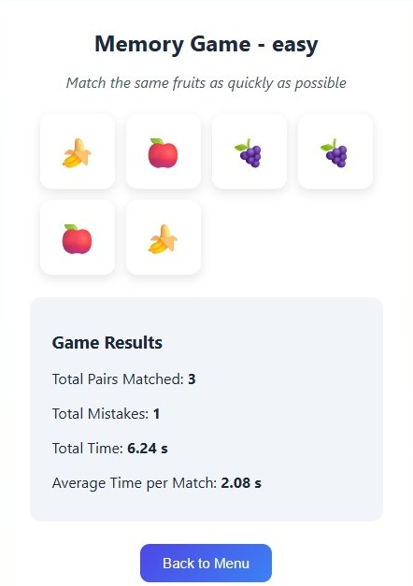

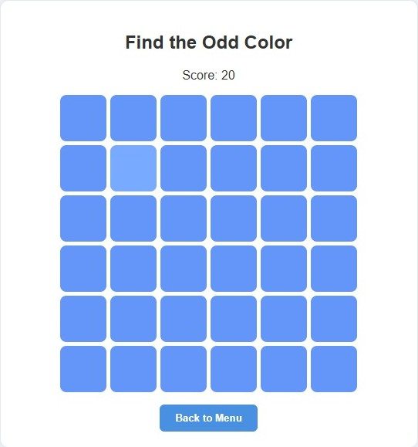

Fig.5 Memory Game interface with real-time scoring
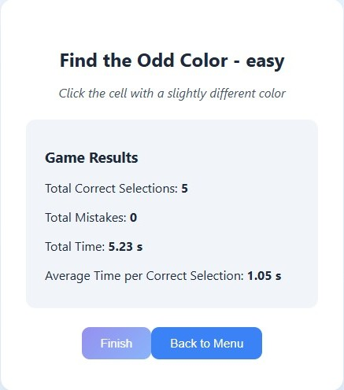


Fig. 6 Therapist Dashboard main view

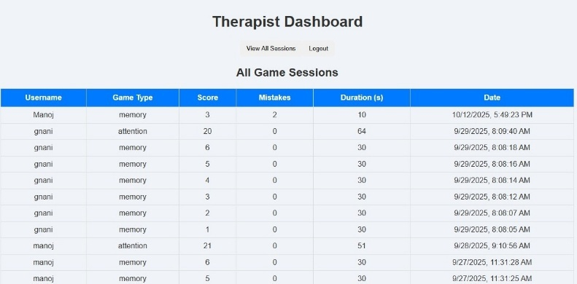
Fig. 7 Therapist Dashboard results table showing user performance metrics
- CONCLUSION
The CCRT is a virtual reality-based digitally accessible training program that has proven to be effective in enhancing the cognitive abilities of children with disabilities such as memory, attention, and executive skills. Featuring personalized cognitive games, real-time performance feedback and remote therapist monitoring, the platform aims to close treatment adherence gaps between clinic-based therapy and home. The interface is dual-role for parents/students and therapists to provide both engagement and supervision, while adaptive difficulty levels customize training based on the user’s performance. Quantification of progressive enhancement in accuracy, reaction time and memory formation was evident, validating usability, scalability and the potential therapeutic reliability of the program in practical application with patients.
The CCRP significantly advances integrative digital health by enabling effective ongoing at-home cognitive practice with limited professional involvement. An Embedded analytics on the therapist dashboard would support the process of data driven review, assist professionals with identifying for whom treatment is not working well, and inform adaptation of intervention in response. The intuitive gameplay and game-based learning keep users excited, active, and engaged with the content so they will learn more. Future developments include automation of progress prediction using AI, large scale data storage in the cloud for analytics, and development of multilingual interfaces to expand access among diverse populations.

REFERENCES
- Kumar, S., Sirisala, S., Babu, G.N., Ramakrishna, K. & Lakshmi, N.V.M. (2024) Computerized Cognitive Retraining Program for Home Training of Children with Disabilities. In: Proceedings of the 2nd International Conference on Sustainable Computing and Smart Systems (ICSCSS 2024). IEEE. DOI: 10.1109/ICSCSS60660.2024.10625417.
- Prakash, P., Mukunth, J., Elangovan, K. & Dhanush Raja, A.K. (2024) Computerized Cognitive Retraining Program for Children with Disabilities. In: Proceedings of the 2024 International Conference on Power, Energy, Control and Transmission Systems (ICPECTS 2024). IEEE. DOI: 10.1109/ICPECTS62210.2024.10780401.
- Soni, A.K., Sharma, A.G., Mehta, P.K. & Gupta, S.R. (2025) Efficacy of home-based computerized adaptive cognitive retraining (CACT) in patients with post-stroke cognitive impairment. Scientific Reports. Available at: https://www.nature.com/articles/s41598-025-85511-3 [Accessed 1 Oct. 2025].
- Robledo-Castro, S., Castillo-Ossa, L. & Corchado, J. (2024) Effects of computerized cognitive training vs. paper-and-pencil training on executive functions and attention in elementary school children. Computers in Human Behavior Reports. Available at: https://www.sciencedirect.com/science/article/pii/S2215016124003297 [Accessed 1 Oct. 2025].
- Wu, Y., Chen, M., Zhang, X. & Yuan, L. (2023) Computer-based multiple component cognitive training in children with ADHD: A pilot study. Child and Adolescent Psychiatry and Mental Health. Available at: https://capmh.biomedcentral.com/articles/10.1186/s13034-022-00553-z [Accessed 1 Oct. 2025].
- Westwood, Y., Parlatini, V., Rubia, K., Cortese, S. & Sonuga-Barke, E.J.S. (2023) Computerized cognitive training in attention-deficit/hyperactivity disorder (ADHD): A meta-analysis of randomized controlled trials. Frontiers in Psychology. Available at: https://www.researchgate.net/publication/371007196 [Accessed 1 Oct. 2025].
- Robledo-Castro, C., Ariza-Colpas, A. & Cruz, A. (2023) Artificial cognitive systems applied in executive function stimulation and rehabilitation programs: A systematic review. JMIR Mental Health.
- Sciancalepore, F., Pellegrini, L. & Cattaneo, G. (2022) Computer-based cognitive training in children with primary learning disabilities: A systematic review. Journal of Autism and Developmental Disorders.
- Farghaly, A., El-Sayed, R., El-Kady, A. & Shaker, H. (2022) Training second-grade dyslexic students using a computerized program in Asyut, Egypt. Egyptian Journal of Neurology, Psychiatry and Neurosurgery, 58(57). DOI: https://doi.org/10.1186/s41983-022-00480-y [Accessed 1 Oct. 2025].
- Nappo, R., Brancaccio, M., Pascotto, A. & Valenti, G. (2022) Computerized training of executive functions in a child with specific learning disorders: A descriptive study. Available at: https://www.researchgate.net/publication/366043186 [Accessed 1 Oct. 2025].
- Bansal, P. & Singh, R. (2021) Effectiveness of computer-based cognitive retraining for children with specific learning disabilities. Journal of Cognitive Education and Psychology.
- Game-based Digital Cognitive Training Program Study. (2021) Effectiveness of digital game-based training in children with neurodevelopmental disorders. Applied Sciences, 11(18). Available at: https://www.mdpi.com/2076-3417/11/18/8582 [Accessed 1 Oct. 2025].
- Tsiakas, P., Kyriazakos, A. & Kaldoudi, E. (2020) Adaptive digital systems for cognitive intervention: A review of methods and applications. Frontiers in Digital Health.
- Benyakorn, S., Tiamkao, S., Siripornpibarn, T. et al. (2018) Computerized cognitive training in children with autism and intellectual disabilities: Feasibility and satisfaction study. JMIR Mental Health.
- Corti, C., Rossini, A., Rizzi, S. et al. (2018) Feasibility of a home-based computerized cognitive training in adolescents with brain damage. PLOS ONE.
- Park, J.H., Kim, S.E., Oh, D.W. et al. (2015) A randomized controlled trial of the computer-based cognitive rehabilitation program for children with developmental disabilities.
- NCERT. (n.d.) Including Children with Special Needs. New Delhi: National Council of Educational Research and Training. Available at: https://ncert.nic.in/pdf/publication/otherpublications/SpecialNeeds.pdf [Accessed 1 Oct. 2025].
- University of Alabama at Birmingham – Traumatic Brain Injury Model System. (n.d.) In-home Cognitive Stimulation Guidebook. Birmingham: UAB. Available at: https://uab.edu/medicine/tbi/images/TBIMS/PDF/In-home_Cognitive_Stimulation_Guidebook_-_Final.pdf [Accessed 1 Oct. 2025].
- JSS College of Physiotherapy. (n.d.) Training Manual for Children with Special Needs. Mysuru: JSS College of Physiotherapy. Available at: https://jssphysiotherapy.edu.in/assets/documents/departments/Training_Manual_for_chidlren_with_special_needs.pdf [Accessed 1 Oct. 2025].
- Westwood, S.J., Parlatini, V., Rubia, K., Cortese, S. & Sonuga-Barke, E.J.S. (2023) Computerized cognitive training in attention-deficit/hyperactivity disorder (ADHD): A meta-analysis of randomized controlled trials with blinded and objective outcomes. Frontiers in Psychology. Available at: https://www.researchgate.net/publication/371007196_Computerized_cognitive_training_in_attention-deficithyperactivity_disorder_ADHD_a_meta-analysis_of_randomized_controlled_trials_with_blinded_and_objective_outcomes [Accessed 1 Oct. 2025].

